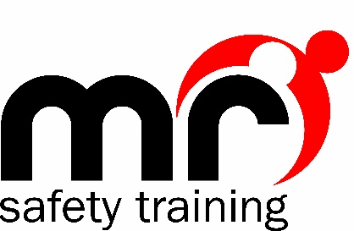

Covid-19 Learner Training Instructions

It is imperative that when MR Safety Training (MRST) conducts training courses, everyone concerned is kept safe at all times.
DO NOT come to a training course if you or a member of your household have tested positive for Coronavirus. You must self-isolate and seek medical advice.
DO NOT come to a training course if you are awaiting results of a Covid test.
IF YOU develop any of the Covid symptoms during any MRST training session, you will be asked to leave immediately, self-isolate and seek medical guidance.
IF YOU develop any Covid symptoms within 2 days following any MRST training session, you are required to inform MRST office team, as we need to inform others using our Track & Trace system.

Before you come to training:
We strongly recommend all learners and trainers to take a Covid Lateral Flow Test to make sure they are free from Covid before attending a training course. We ask everyone to do this to minimise the risk of virus spread.
If you do test positive, please make sure you let our office team know beforehand so we can re-schedule your training. Please note, we will need a picture of your test result for this purpose.

When you arrive:
Please only bring personal items which you need for the time of the course. Excessive personal items increase the risk of infection spread.
When you arrive to the course please make sure you wash your hands upon arrival either by normal handwashing or by using hand sanitiser.
Antibacterial hand wash and hand sanitiser will always be available in the training venue.
Gloves will be provided for practical activities
We strongly encourage all learners to wear a face mask / face covering during the course, please bring a face mask with you for this purpose.
Make sure you always keep social distanced away from other people before, during and after the training course.
These measures will reduce the risk of any virus spread.

For First Aid courses:
Manikins will be sterilised before use and after use, with fresh lungs for each training session
You will have your own training pack and book to use for the duration of the course and to keep afterwards.
You will not be asked to practice skills repeatedly, but you will be asked to demonstrate to ensure competency.
Please wash your hands or use sanitising hand gel before and after any practical activity.
Each training venue has adequate ventilation to maintain air circulation.
All training sessions will be adapted to fully limit personal contact with others.

The Training Room:
It is important to maintain socially distanced from other people during the course, so when entering the room make sure you walk at a safe distance from others to your seat, and do the same when exiting the room, and when using toilet facilities.

Refreshments:
Unfortunately, MRST will not be providing refreshments on any courses during the Covid pandemic. If you wish to have refreshments, please bring your own and dispose of waste in the bins provided.

Failure to follow any of the above guidelines will result in you being asked to leave the course immediately.

We thank you for following these instructions!!

