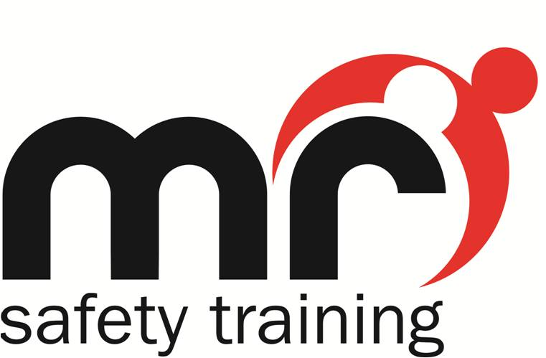
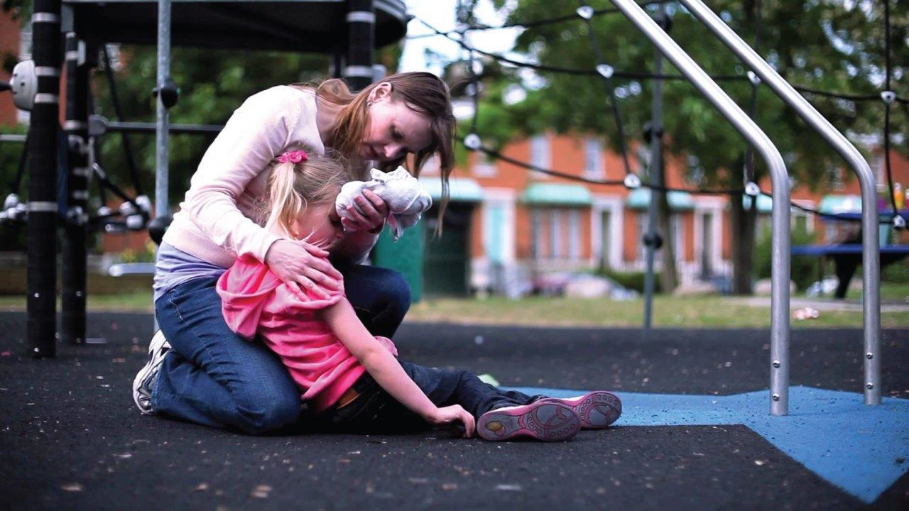

Condition Factsheet - Sepsis

Overview of Sepsis
Sepsis is a rare but serious complication of an infection, whether this be fungal, viral or bacterial. It can affect multiple organs or the entire body
Around 37,000 people die each year as a result of Sepsis, and can affect anyone of any age, especially after an injury, or an infection.
Those who are particularly vulnerable are:
- those with an existing medical condition, or in the process of receiving medical treatment which weakens their immune system
- those who are already in hospital with a serious illness
- those who are very young or very old
- those who have just had surgery, or have wounds or injuries as a result of an accident
During a normal infection, the body produces white blood cells to fight the infection, and destroy the germs causing it. However, if the immune system is weak or an infection is particularly severe, then it can quickly spread through the blood into other parts of the body. The immune system then goes into over-drive, widespread inflammation occurs, body tissues are damaged, and it interferes with blood flow around the body.
On some occasions, the condition can progress into "Septic Shock". This is where the blood pressure drops dangerously low.

Symptoms in children under 5:
- Mottled, blueish or pale skin - Very lethargic or difficult to wake
- Feels abnormally cold to touch - Breathing is very fast
- A rash which doesn't fade when you press it - Convulsions
- A temperature over 38 degrees C (babies aged under 3 months)
- A temperature over 39 degrees C (babies aged between 3 and 6 months)
- Any high temperature and the child shows no interest in anything
- A low temperature below 36 degrees C (check three times within a 10 minute period)
- Finding it much harder to breathe than normal - Making "grunting" noises with every breath
- Not had a wee for 12 hours - Eyes look sunken
- Appears weak, a constant whining, or continuous crying - Not responding, or very irritable
- Stiff neck, especially when trying to look up or down

Symptoms in older children and adults:
- A high temperature (a fever) or low body temperature - Chills and shivering
- A fast heartbeat - Fast breathing

Symptoms of Septic Shock:
- Feeling dizzy or faint - A change in mental state
- Diarrhoea - Nausea / Vomiting
- Slurred speech - Severe muscle pain
- Severe breathlessness - Urinating less than normal
- Cold, clammy, pale or mottled skin - Loss of consciousness

Treatment:
Sepsis and Septic Shock are medical emergencies
If you think someone has one of these conditions, or if you are concerned in any way, dial 999 or go to your nearest A&E.
Medical professionals will perform a set of measurements, looking at temperature, heart rate and breathing rate. They will usually perform a blood test as well.
If Sepsis is spotted early, then a simple case of antibiotics, and most people make a full recovery.
Those with severe Sepsis will need to be admitted to hospital. Severe Sepsis can interfere with the function of vital organs, and can therefore be fatal.
Sepsis is treatable, if spotted early, and treated quickly.
Always trust your gut instinct!!

Recovery from Sepsis:
Recovery can depend on the severity of Sepsis the person has experienced and their vulnerability. It can have long lasting physical or psychological effects including:
- Feeling lethargic or excessively tired - Muscle weakness
- Swollen limbs or joint pain - Chest pain or breathlessness

(Source of information: www.nhs.co.uk)

Delivering Safety Training With Professionalism & Passion!
T: 0113 2100600 E: info@mrsafetytraining.com W: www.mrsafetytraining.com

