Part A

Number Name Date

Part B
Person Affected Person Reporting

Name Name

Address Address

Occupation Occupation
Incident Details

Date Time

Address & Location of Incident

Full Description of Incident

Injury

Action Taken /
Recommendation(s) Given

Guidance Notes
Draw on the diagram where the injury / injuries are. Be as precise as possible in location and size of injury

Where was the injury?

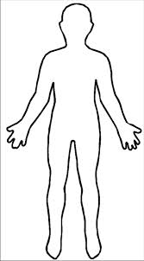

Front Back

Signatures
Casualty / Parent / Carer
T: 0113 2100600
E: info@mrsafetytraining.com
W: www.mrsafetytraining.com

First Aider
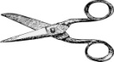
___________________________________________________________________________________________

Part C
Summary For Casualty / Parent / Carer
Name Date Time

Location of Incident
Guidance Notes
Summarise here the details of the incident from the information above
Give this section to the casualty or parent / carer to take away with them
Note to casualty / parent / carer
If condition develops, please present this to medical staff to give them background information of incident

Description

Injury

Action Taken

T: 0113 2100600 E: info@mrsafetytraining.com W: www.mrsafetytraining.com

